Project Development Phase
Date | 13 July 2026
Team ID | SWTID-2026-4732
Project Name | India's Agricultural Crop Production Analysis
Maximum Marks

Preprocessing Steps:
- Collected the agricultural cultivation dataset (1997–2021) from the source.
- Imported the dataset into Tableau Desktop.
- Checked for missing (null) values and handled them appropriately.
- Removed duplicate records to ensure data accuracy.
- Corrected inconsistent data formats and standardized column names.
- Verified data types (State, Crop, Season, Year, Area, Production).
- Converted numerical fields (Area and Production) to numeric data types. • Organized the data for state-wise, crop-wise, season-wise, and year-wise analysis.
- Created calculated fields for KPIs such as Total Production and Total Area.
- Validated the cleaned dataset before creating visualizations.
Business Questions:
  - Which states have the highest agricultural production?

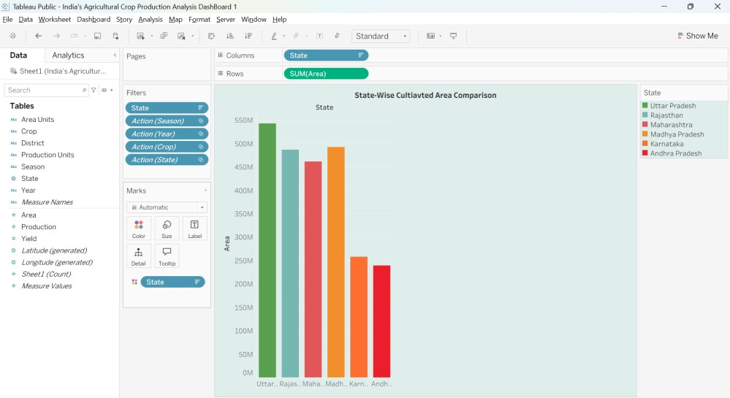

2.Which crops contribute the highest production in India?

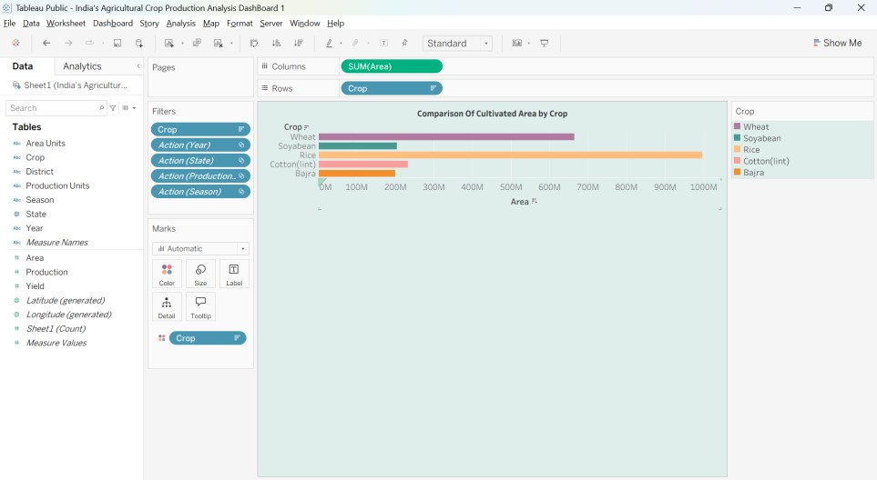
  - How has agricultural production changed from 1997 to 2021?

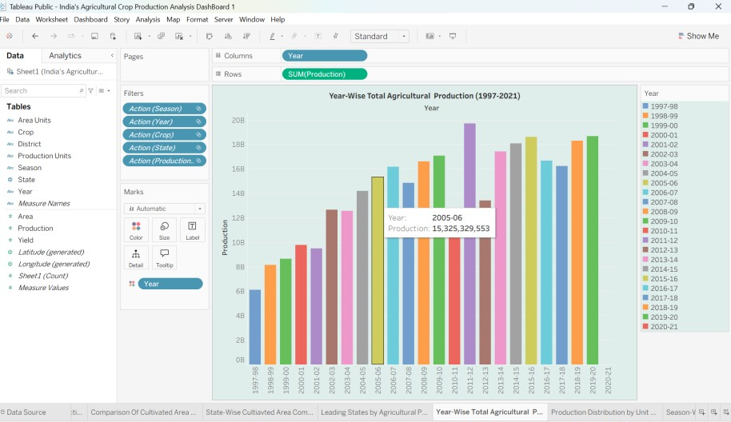

  - Which season produces the highest crop yield?

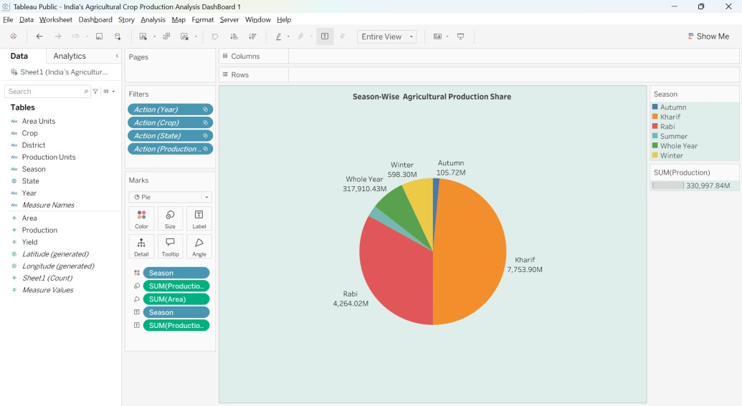
  - Which states have the largest cultivated area?

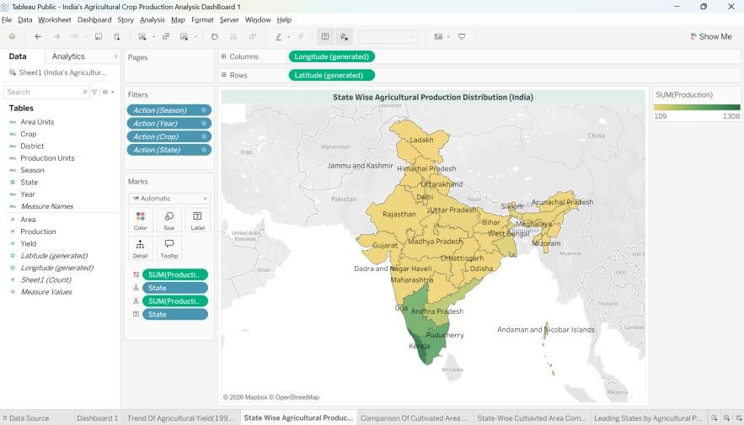
  - Which crops show consistent growth over the years?

